- DNS Server Configuration Theory

Q1. Install and set up a DNS server on your local machine or a VM using BIND (Linux) or Simple DNS Plus (Windows), then create a new DNS zone for the domain musicmania.in?

Answer
To install a DNS server on Windows and create a new DNS zone named musicmania.in.
- Software Used: Simple DNS Plus
- Steps:
- Download and install Simple DNS Plus on the Windows computer.
- Open Simple DNS Plus.
- Click Add Zone.
- Choose Primary Zone.
- Enter the zone name: musicmania.in
- Keep the default zone file name, for example: musicmania.in.dns
- Click OK / Create.
- The new zone musicmania.in will appear under the Zones section.
- Select the zone to verify that it has been created successfully.
- Save the configuration if required.
- Observation:
The DNS server started successfully and the new zone musicmania.in was created and loaded.

- Result:
A new DNS zone named musicmania.in was successfully created in Simple DNS Plus.

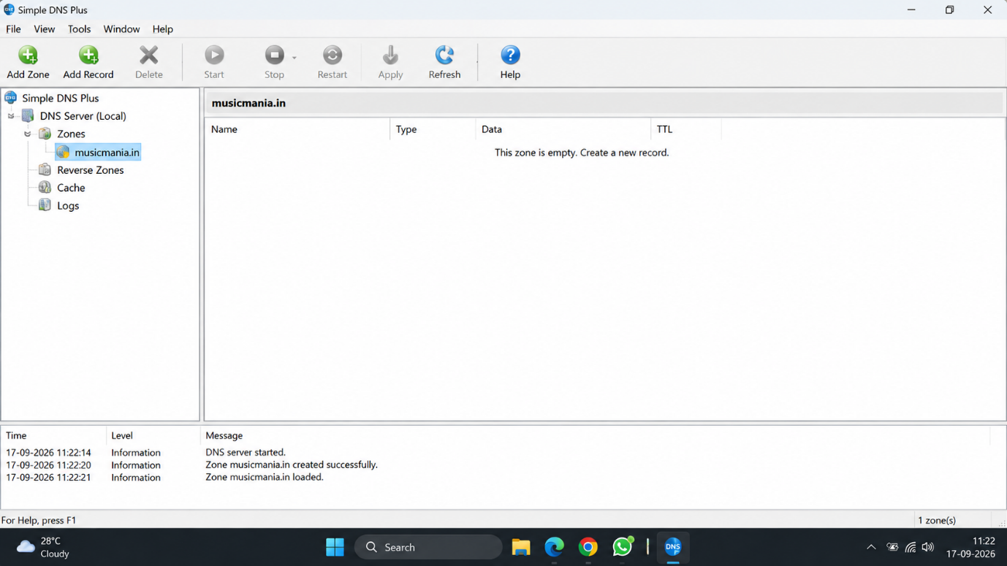

Q2. Add an A record in your DNS server configuration to map www.musicmania.in to the IP address 192.168.1.50, then use the nslookup or dig command to verify the mapping works?

Answer
To add an A record for www.musicmania.in and map it to the IP address 192.168.1.50.
- Steps:
- Open Simple DNS Plus.
- Select the zone musicmania.in from the left side.
- Click Add Record.
- Select A (Host Address) as the record type.
- In the Name / Host field, enter: www
- In the IP Address field, enter: 192.168.1.50
- Click OK / Save.
- Confirm that the new record appears as: www A 192.168.1.50
- Open Command Prompt.
- Run this command: nslookup www.musicmania.in 127.0.0.1
- Check the output. It should show: Name: www.musicmania.in
Address: 192.168.1.50
- Result:
The A record was created successfully, and www.musicmania.in correctly resolved to 192.168.1.50.
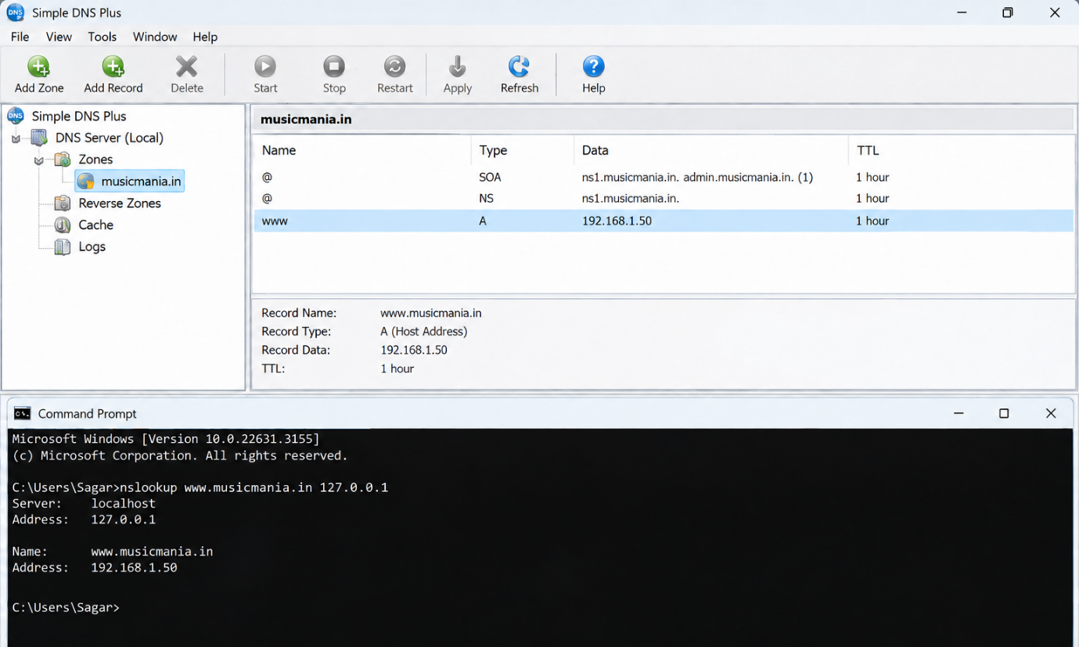

Q3. Simulate a typo by adding a CNAME record for play.musicmania.in that points to www.musicmania.in, then test if accessing play.musicmania.in resolves to the correct IP address?

Answer
To create a CNAME record so that play.musicmania.in points to www.musicmania.in.
- Steps:
- Open Simple DNS Plus.
- Select the zone musicmania.in.
- Click Add Record.
- Select CNAME (Alias) as the record type.
- In the Name / Alias field, enter:
play
- In the Canonical Name / Target field, enter:
www.musicmania.in
- Click OK / Save.
- Confirm that the record appears like this:
play CNAME www.musicmania.in
- Open Command Prompt.
- Run: nslookup play.musicmania.in 127.0.0.1
- Check the result. It should show that play.musicmania.in is an alias of www.musicmania.in and resolves to: 192.168.1.50
- Expected Output:
- Name: www.musicmania.in
- Address: 192.168.1.50
- Aliases: play.musicmania.in
- Result:
The CNAME record was created successfully. play.musicmania.in points to www.musicmania.in and resolves to 192.168.1.50.

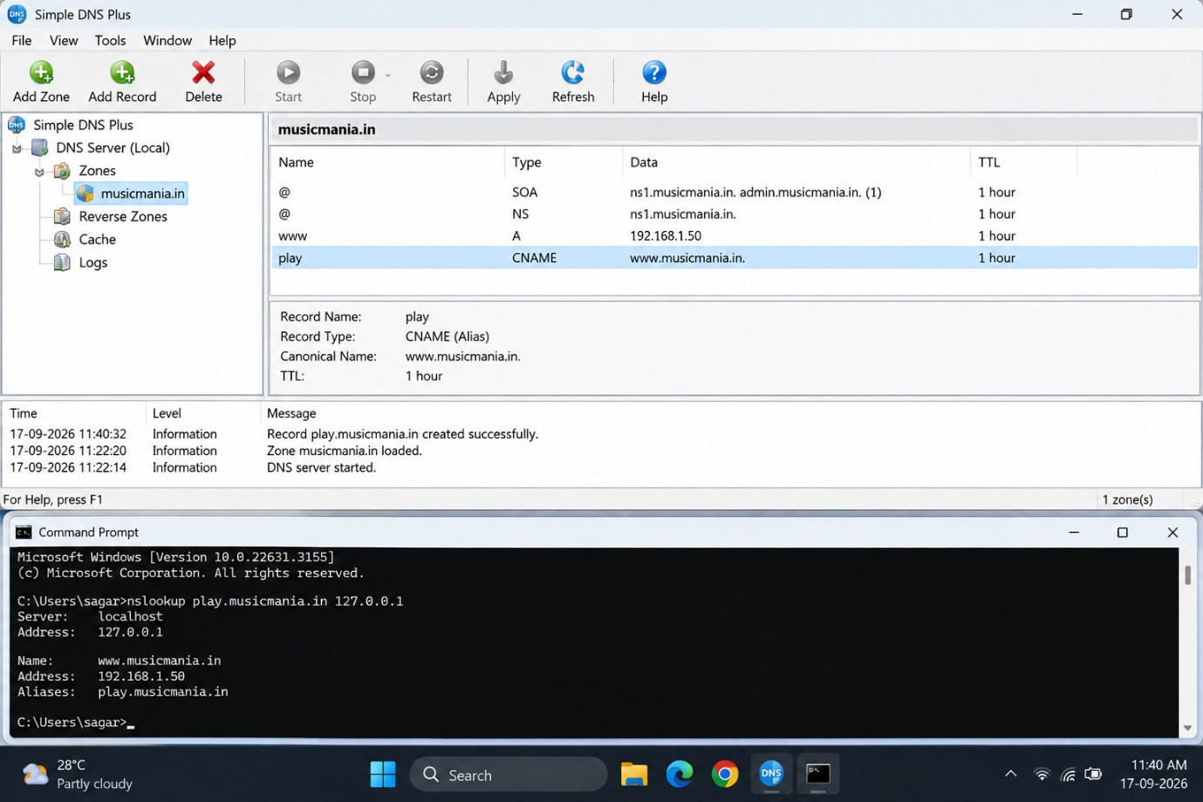

Q4. Your DNS server is not resolving the domain musicmania.in as expected. Document the step-by-step troubleshooting process you would follow, including checking configuration files, restarting the DNS service, and testing with nslookup or dig.<br><br><em><strong>Hint:</strong> Include at least three different troubleshooting commands or checks in your documentation.</em>?

Answer
To find and fix the problem when the DNS server is not resolving musicmania.in correctly.
- Steps:
- Open Simple DNS Plus and check that the zone musicmania.in exists.
- Check that the required DNS records are correct, for example: www A 192.168.1.50 play CNAME www.musicmania.in
- Make sure the DNS server is running. If needed, click Restart in Simple DNS Plus.
- Open Command Prompt and check the DNS server using:
nslookup www.musicmania.in 127.0.0.1
- Test the CNAME record using:
nslookup play.musicmania.in 127.0.0.1
- Clear the Windows DNS cache using: ipconfig /flushdns
- Check the computer's DNS configuration using: ipconfig /all
- Make sure the computer is using the correct DNS server address.
- Restart the DNS service again and repeat the nslookup test.
- Expected Result:
  - www.musicmania.in → 192.168.1.50
  - play.musicmania.in → www.musicmania.in → 192.168.1.50
- Result:
By checking the zone and DNS records, restarting the DNS service, clearing the DNS cache, and testing with nslookup, DNS resolution problems can be identified and fixed.

